The Baby Depot Year End Report

December 2022


Incorporated Name, Registered Charitable Number, and Website

The Baby Depot, #81762 9520 RR 0001, www.thebabydepot.org

Descriptive Report

We would like to express a heartfelt THANK YOU for your generous, donation of $6000 towards The Baby Depot! Your continued support over the years does not go unrecognized. The global COVID-19 pandemic continues to cause more families in need to face an uncertain reality. Thus, the importance of our mission to recycle clothing and essential baby gear and match it to Hamilton families in need has been even more evident during this uncertain time.
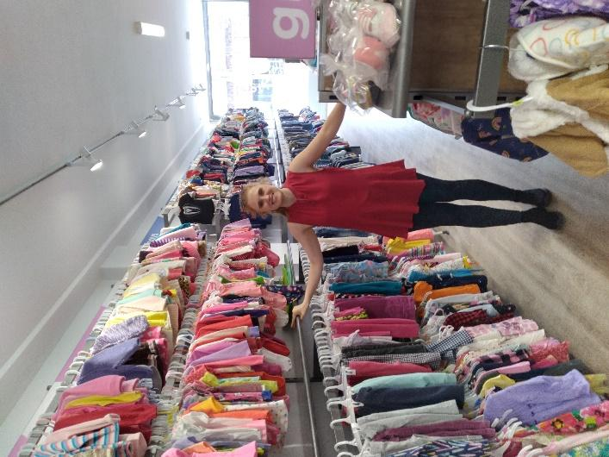
To date in 2022, thanks to your generous support, The Baby Depot has supported 198 babies and their families with approximately 11, 000 pieces of gently used or new clothing, sleeves of diapers, and other essential baby items!

Your contribution to our work has greatly assisted in filling The Baby Depot Boutique with essential baby items and ensuring that no baby in Hamilton does not have the essentials they need in the first year of life because of the financial restraints of their parents. As you will see from attached photos, the baby Boutique space is a beautiful and welcoming space for families to come in and shop for free. No child should begin their journey on this earth without clothing and essential items for daily life. Thank you for joining us as we support Hamilton’s babies in need—it truly takes a village!

Why is The Baby Depot Needed?
Our Program Coordinator, Stephanie Greenaway, in The Baby Depot Boutique!

A major objective of The Baby Depot is to alleviate a major stressor for income-limited parents and equip them with essential baby items for safe parenting. The pandemic has exacerbated the existing inequalities that are in our city. Typically, babies and their needs cost between $10,000 and $15,000 per year, and for lower-income families, the cost of housing and food is prioritized over baby needs. We are seeing more and more families living on the margins be thrust closer and closer into poverty - meaning that parents have to make the impossible choice between providing these essentials for their baby, or keeping a roof over their head and food on the table. What is supposed to be a joy-filled time in people’s lives has become riddled with stress and anxiety as parents question how they will be able to provide for their little ones. By removing these barriers, families no longer have to make that choice, allowing parents to spend their resources on providing a safer and healthier environment for their child(ren). With the support ArcelorMittal has given, families are in a better position to be financially independent and self-sufficient during the early years of raising a child.

The Baby Depot Boutique

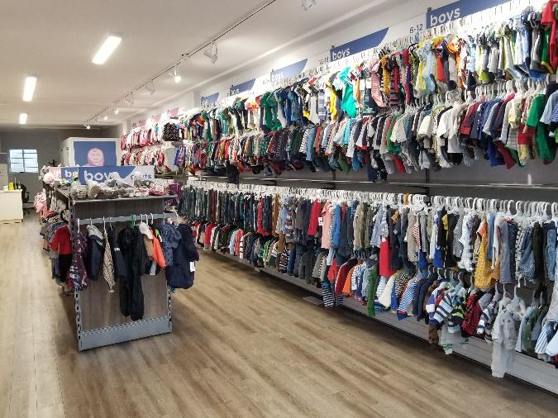
Supported by one full time staff, one summer student, and a community of volunteers, The Baby Depot provides a year's worth of essential baby items (clothes, diapers, wipes, lotions, cribs, etc.) to families in need in Hamilton and the surrounding area to help them safely take care of their babies. Our 9-year-old program relies on the generous support of the community to donate new and gently-used clothing and essential baby items at our storefront location, The Baby Boutique on Barton Street. All of our donated clothing and items are carefully inspected, sorted and washed by our Program Coordinator and dedicated volunteers. Social agencies from across the city request support for families with the greatest need.

To continue to respond to the increased need throughout COVID19, in July 2021 we moved to a new, larger space in the East end of Hamilton where we opened The Baby Depot Boutique—a space where families can come in for a dedicated shopping experience to choose their own clothing and baby items for their families! Thanks to the generosity of the Hamilton community, our space has been overflowing with donations! A new larger space has allowed us to continue to accept donations, including larger essential baby items like high- chairs, exer-saucers, and strollers.

This new space has been an opportunity to bring dignity into the process for the families that we serve. By choosing their own clothing in a safe environment to outfit their baby in and picking the stroller, bassinet and exer-saucers for their babies, parents have felt encouraged in their role as caregivers to provide for their families. Many of these families live with barriers and feel less than in almost all circumstances.

Our new location is in close proximity to the unique individuals and vulnerable populations that we serve which includes many BIPOC communities; marginalized communities, all racialized and Indigenous (First Nations, Metis, Inuit) communities and newcomers to Canada, people with low-income and living in poverty and many single-parent families.

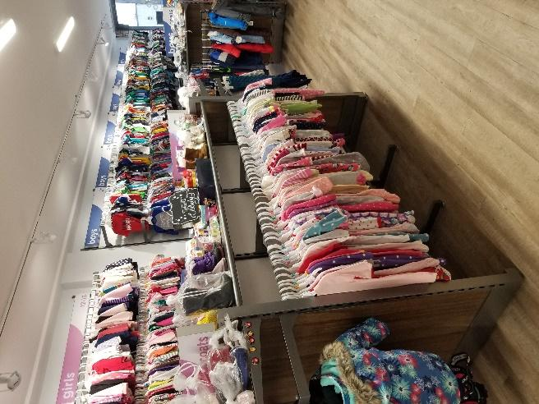
Here are some quotes from families that have come into The Baby Depot Boutique since we opened our doors in July 2021:
- “I really appreciated all the help our family got and I would love to give some items that another family may need”
- “This is so amazing! I'm going to tell all my friends!"
- "Just wanted to thank you for this organization and how you support families in tough places. I really appreciated being able to use your service"
- “I just wanted to thank you so much for the items that you provided for the family. I know that she really appreciated it because when I visited her yesterday she had the baby items folded and neatly organized - it was great to see.”

We are grateful for the opportunity to have opened The Baby Depot Boutique and to bring dignity into the process for those that we serve.

FUTURE PLANS

Since The Baby Depot began in 2013, we have helped just over 900 babies which means we have provided over 900 year’s worth of clothing and baby essential items to families in need! We receive an abundance of new and gently-used donations from the Hamilton community and continue to work with our partner agencies to identify and support babies and families with the greatest need in Hamilton.

So far in 2022, our small team at The Baby Depot Boutique has supported 198 babies and families. We know that the need will be greater in 2023 and we are compelled to ensure that we can continue serving our littlest neighbours by providing them with their basic needs in that first, critical, year of life.

In 2-5 years, we would like to host an additional space called The Baby Centre where families in need could still choose a year’s worth of clothing for their children; but they could also access other services like ‘Baby and Me’ classes; Lactation consultants; Midwives and so many more services that are not usually accessible to families living on the margins.

For the coming year, our ultimate goal is to distribute 13,500 health and hygiene items (clothing, diapers, cribs etc.) to at least 200 babies and their families in Hamilton.

We are so grateful for your support as we continue to work together to bring transformative change by communicating value, dignity and hope to the families we serve in Hamilton.

